Name
Professor
Course
School
Rock Mechanics- Solutions
Q1. The intact rock can be defined as the polycrystalline or continuous solid seen between discontinuities. This is the unfractured block seen between discontinuities in the general rock mass. Discontinuities are the faults and joints breaking up the rock mass. They are the lines of weakness found in the rock mass. The definition of the rock mass is the medium found in situ and composed of blocks of intact rock that are divided by discontinuities like folds, bedding planes, joints, faults, and sheared zones. It is the indistinct and large body of solid earth comprising features in terms of schistosity, folding, jointing, et cetera. Discontinuity has a considerable effect on the structure of the rock as the block tends to change the arrangement of mineral elements to gain stability. Hence, there are adverse effects under low stresses and strains. The impact of stresses along the discontinuity is extreme, as it is a line of weakness. The bearing strength of the block is also reduced as the material deforms under the application of a load. The discontinuities allow spaces for deformation of the structure. Discontinuities are also primarily affected by the groundwater effect as water can seep through the joints and faults created. The mechanical and physical characteristics of the trapped water are different from standard water properties. Again, discontinuities are responsible for the different results found in the laboratory and in situ testing. The results found in situ are different from the laboratory’s as the rock is not yet disturbed. Discontinuities play a significant role in disturbing rock samples when being transported to the laboratory.
Q2. Feldspar and silica are the most common minerals on the crust of the earth, and both contain silicates as the building blocks. They are both found in most rocks that form the earth’s crust forming the larger percentage. The differences involved are seen in specific gravity as feldspar has a specific gravity of 2.56-2.7 while silica has 2.2-2.3. Also, they have different hardness in that feldspar has a Mohr scale hardness of 6-6.5 while silica is at 7. Silica is colorless while feldspar has a luster that is pearly on the cleavage faces. The other difference is the presence of an aluminum element in feldspar that is absent in silica. For the feldspar group, the mineral example is the orthoclase or potassium feldspar (KAlSi₃O₈) and plagioclase (Ca, Na)AlSi₃O₈) that are characterized by cleavage with two planes at perpendicular to each other. In silica, the mineral example is the quartz (SiO₂) that is characterized by the absence of cleavage.
Q3. There are a few differences that can be seen between an igneous rock and a sedimentary rock. Igneous rocks are harder in comparison to sedimentary rocks and are either dark or light, but for the sedimentary rocks, there are several color ranges. Most igneous rocks are non-porous as compared to the sedimentary rocks which have a high content of fossils. Also, in terms of reaction, igneous rocks are more dormant compared to sedimentary rocks that are relatively high reactive. Sedimentary rocks tend to form in layers as opposed to igneous rocks that are massive intact rocks. Igneous rocks are huge features relative to sedimentary rocks that are mainly of quartzite nature.
Q4. Faults are the crustal strata fractures along which substantial shear displacement of the adjacent rock has occurred concerning each other. They are formed as a result of tectonic activities.
a).
The figure below represents the various components of a fault.
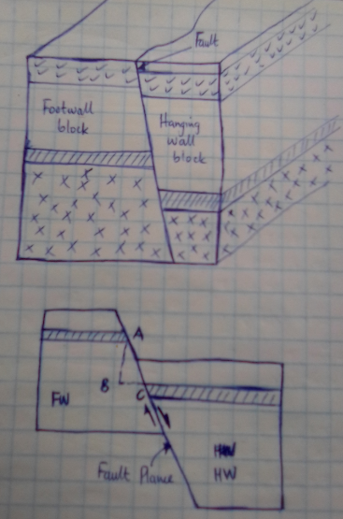
Figure 1. Elements of a fault.
AC is the net slip; AB is the throw or the vertical slip; BC is the heave or the horizontal slip; <BAC is the hade of the fault. The shaded arrows illustrate the direction of the walls (footwall- FW and hanging wall- HW).
b).
The various types of faults are as illustrated in the following figures.
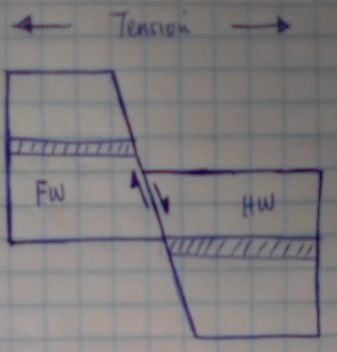
Figure 2. Normal fault.
Normal faults are a result of tensional stresses that causes the FW and HW to move, as illustrated in the figure above. The HW moves downwards to the FW.
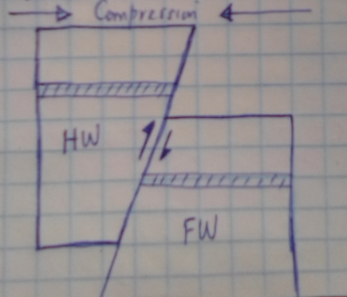
Figure 3. Reverse fault.
Reverse faults are a result of compressional stresses that causes the FW and HW to move, as illustrated in the figure above. The HW moves downwards to the FW.
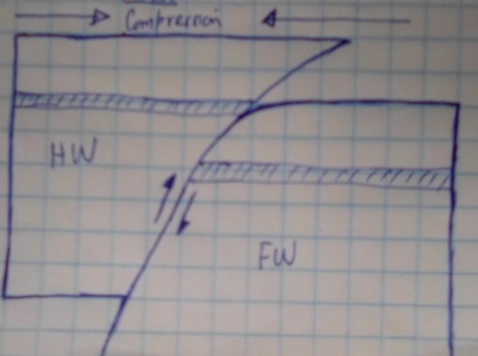
Figure 4. Thrust fault.
Thrust faults are a result of compressional stresses that causes the FW and HW to move, as illustrated in the figure above. The FW dips at about 45 degrees while the overlying rock is displaced at about 90 degrees on the underlying rock.
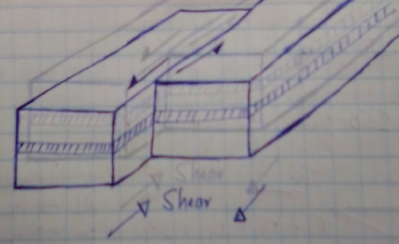
Figure 5. Strike-slip fault.
Strike-slip faults are a result of shearing stresses that causes the FW and HW to move, as illustrated in the figure above. The movement of the walls is along the line of weakness in a horizontal direction, as shown above, which is parallel to the fault plane’s strike.
Q5.
- is the syncline of the fold, and it is mainly composed of weathered rock sediments, hence the strata expected is a sedimentary rock.
- is the anticline of the fold, and the primary composing is a hard rock of igneous origin, thus the anticipated strata is an igneous rock.
- is a joint as there is a little movement of the rocks seen, and the type of strata expect is a hard rock of igneous or sedimentary rock.
- is bedding as the surfaces are parallel to the surface of the deposition surface, and the anticipated strata is a sedimentary rock.
- is a schistosity, as seen with the prismatic arrangement of the mineral grains, and the expected strata are metamorphic rock.
- is a fracture as the rock blocks have moved, and the description of the geological feature is a hard rock, with strata of igneous or sedimentary rock.
- is a fault, as seen by the fault line, and the description is a hard rock, with strata of sedimentary or igneous rock.
- is foliation as seen by the parallel orientation of the minerals, and the strata expected is a metamorphic rock.
Q6. The quadrant and azimuthal forms are as respectively indicated below:
a) N 32⁰ W or 328⁰
b) S 32⁰ E or 032⁰
c) S 32⁰ W or 212⁰
d) S 32⁰ E or 122⁰
e) 45⁰ W or 270⁰
f) 45⁰ S or 180⁰
Q7. The formulas to be followed for core recovery ratio (CR) and rock quality designation (RQD) are as illustrated below.
CR % = $\frac{length of the recovered rock core}{total length of the core run }x 100$ and
RQD % = $\frac{\sum{length of the pieces of cores that are equal to or greater than 100mm}}{total length of the core run}x 100$
a) CR % = $\frac{102 cm}{150 cm }x 100=68 \%$
RQD % = $\frac{\sum{10+20+46+26}}{150}x 100=68 \%$
Hence, from the table of allowable bearing pressure by Peck et al., the allowable bearing pressure is between 6.5 and 12 MPa.
b) CR % = $\frac{144-\left(2x7\right)cm}{150 cm }x 100=86.7 \%$
RQD % = $\frac{\sum{12+16+18+12}}{150}x 100=38.7 \%$
Hence, from the table of allowable bearing pressure by Peck et al., the allowable bearing pressure is between 3 and 6.5 MPa.
c) CR % = $\frac{118 cm}{150 cm }x 100=78.7 \%$
RQD % = $\frac{\sum{38+10+16}}{150}x 100=42.7 \%$
Hence, from the table of allowable bearing pressure by Peck et al., the allowable bearing pressure is between 6.5 and 12 MPa.
d) CR % = $\frac{300-(2+1+1+4) cm}{300 cm }x 100=97.3 \%$
RQD % = $\frac{\sum{12+14+10+20+12+14+12+12+32}}{300}x 100=46 \%$
Hence, from the table of allowable bearing pressure by Peck et al., the allowable bearing pressure is between 6.5 and 12 MPa.
e) CR % = $\frac{300-(1+1+1+1) cm}{300 cm }x 100=98.7 \%$
RQD % = $\frac{\sum{16+80+46+10+18+12+16+60}}{300}x 100=86 \%$
Hence, from the table of allowable bearing pressure by Peck et al., the allowable bearing pressure is between 12 and 20 MPa.

